**LAB FILE**

**Introduction to C – Programming**



**Batch:(2023 – 26)**

**BCA 1st YEAR**

**SUBMITTED BY: SUBMITTED TO:**

**Name –ABHISHEK SHARMA MS.POOJA CHAHAR**

**Student ID -2316012165 ASSISTANT PROFESSOR**

**CSIT, GRAPHIC ERA, DDN**

1. Write a program to print “Hello World”.

#include <stdio.h>

int main() {

printf ("Hello World");

return 0;

}

***OUTPUT:***

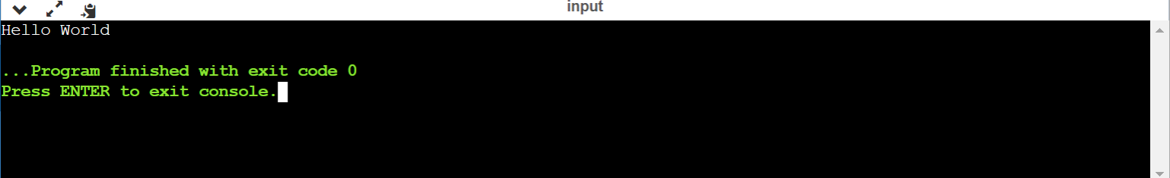

Write a program to add two numbers

#include <stdio.h>

int main() {

int num1, num2, sum;

printf ("Enter two integers");

scanf ("%d %d", &num1, &num2);

//calculate the sum

sum = num1 + num2;

printf ("\nSum of the numbers =%d + %d = %d", num1, num2, sum);

return 0;

}

***OUTPUT:***

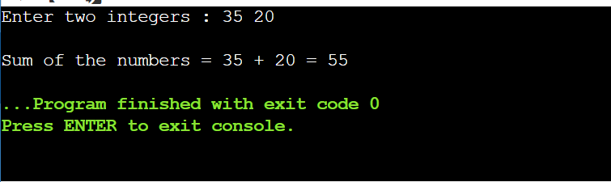

1. Write a program to find area of circle.

#include <stdio.h>

#define pie 3.14

int main() {

float radius, area;

printf ("Enter the radius of the circle : ");

scanf ("%f", &radius);

area = pie * radius * radius;

printf ("Area of the given circle = %.4f", area);

return 0;

}

***OUTPUT:***

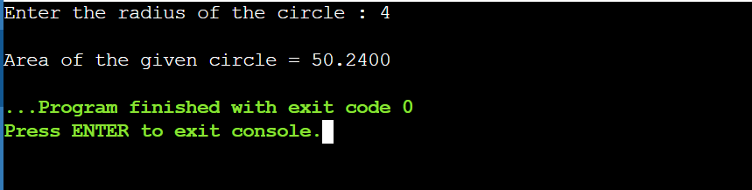

Write a program to divide two numbers.

#include <stdio.h>

int main() {

float a, b;

float div;

printf ("Enter 1st number : ");

scanf ("%f", &a);

printf ("Enter 2nd number : ");

scanf ("%f", &b);

div = a / b;

printf ("\nDivision of the given numbers = %.4f", div);

return 0;

}

***OUTPUT:***

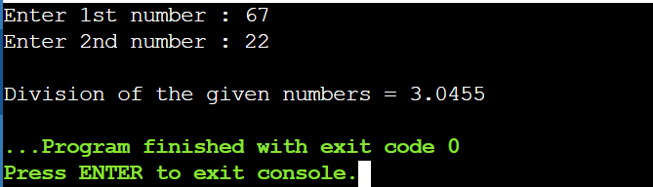

Write a program to print ASCII value.

#include <stdio.h>

int main() {

char c;

printf ("Enter a character : ");

scanf ("%c", &c);

//%d display the integer value of a character

//%c display the actual character

printf ("\nASCII value of %c = %d", c, c);

return 0;

}

***OUTPUT:***

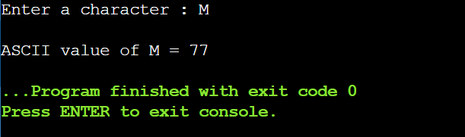

Write a program to multiply floating numbers.

#include <stdio.h>

int main() {

double a, b, product;

printf ("Enter 1st number : ");

scanf ("%lf", &a);

printf ("Enter 2nd number : ");

scanf ("%lf", &b);

product = a * b;

printf ("\nProduct of the given numbers = %.4f", product);

return 0;

}

***OUTPUT:***

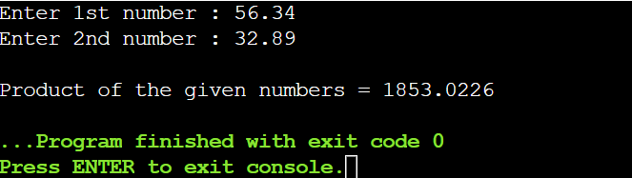

Write a program to SWAP two variables by using third variable.

#include <stdio.h>

Int main() {

int a, b, c;

printf("Enter first number: ");

scanf ("%d", &a);

printf ("Enter second number: ");

scanf ("%d", &b);

c = a;

a = b;

b = c;

printf ("\nSwap numbers are a = %d and b = %d", a, b);

return 0;

}

***OUTPUT:***

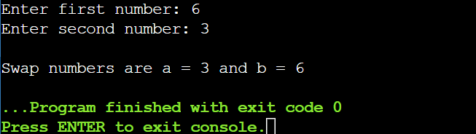

Write a program to SWAP two variables without using third variable.

#include <stdio.h>

int main () {

int a, b;

printf ("Enter 1st number :- ");

scanf ("%d", &a);

printf ("Enter 2nd number :- ");

scanf ("%d", &b);

a = a + b; /*a = %d+%d = %d*/ printf ("\na = %d", a);

b = a - b; /*b = %d-%d = %d*/ printf (" b = %d", b);

a = a - b; /*a = %d-%d = %d*/ printf (" a = %d\n", a);

printf ("\nSwap numbers are :\na = %d \nb = %d", a, b);

return 0;

}

***OUTPUT:***

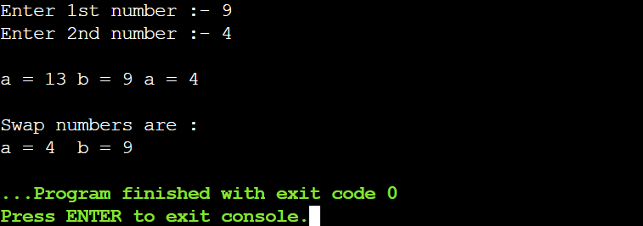

Write a program to SWAP three variables without using fourth variable.

#include <stdio.h>

intmain() {

int a, b, c;

printf ("Enter 1st number: ");

scanf ("%d", &a);

printf ("Enter 2nd number: ");

scanf ("%d", &b);

printf ("Enter 3rd number: ");

scanf ("%d", &c);

a = a+b; printf("\na=%d",a);

b = b+c; printf(" b=%d",b);

c = c+a; printf(" c=%d",c);

a = c-a; printf(" a=%d",a);

b = c-b; printf(" b=%d",b);

c = c-(a+b); printf(" c=%d\n",c);

printf("\nSwap numbers are a = %d, b = %d & c = %d", a, b, c);

return 0;

}

***OUTPUT:***

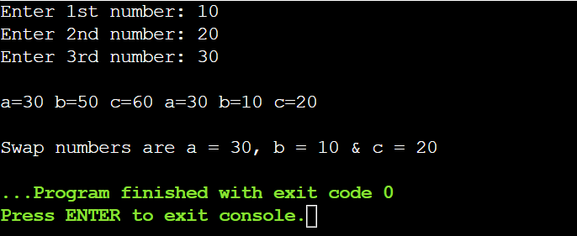

Write a program to find area of rectangle.

#include <stdio.h>

Int main() {

int l, b, area;

printf ("Length of the rectangle : ");

scanf ("%d", &l);

printf ("Breadth of the rectangle : ");

scanf ("%d", &b);

area = l * b;

printf ("\nArea of the rectangle = %d * %d = %d", l, b, area);

return 0;

}

***OUTPUT:***

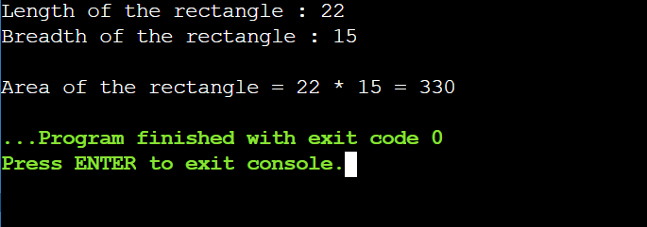

Write a program to find area of square.

#include <stdio.h>

intmain() {

int a, area;

printf ("Enter the side of the square (a) : ");

scanf ("%d", &a);

area = a * a;

printf ("\nArea of the square = %d * %d = %d", a, a, area);

return 0;

}

***OUTPUT:***

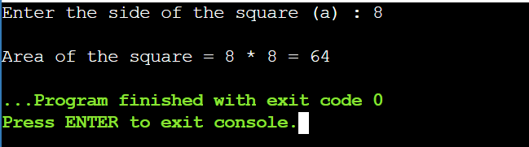

Write a program to find area of right-angle triangle, isosceles triangle, any triangle with three sides.

**AREA OF ISOSCELES TRIANGLE:**

#include <stdio.h>

#include <math.h>

intmain() {

float a, b, c, s, area;

printf("Enter the three sides of the triangle: ");

scanf("%f %f %f", &a, &b, &c);

s = (a+b+c) / 2;

printf("\nSemi-perimeter = %.2f\n", s);

area = sqrt(s*(s-a)*(s-b)*(s-c));

printf("\nArea of the given triangle = %.4f", area);

return 0;

}

***OUTPUT:***

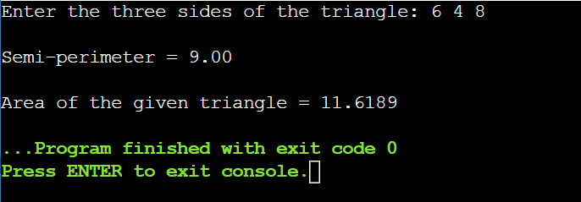

**AREA OF RIGHT-ANGLED TRIANGLE:**

#include <stdio.h>

int main() {

int b, h, area;

printf ("Enter the base of the triangle: ");

scanf ("%d", &b);

printf ("Enter the height of the triangle: ");

scanf ("%d", &h);

area = 1/2 * b * h;

printf ("Area of the triangle = %d", area);

return 0;

}

***OUTPUT:***

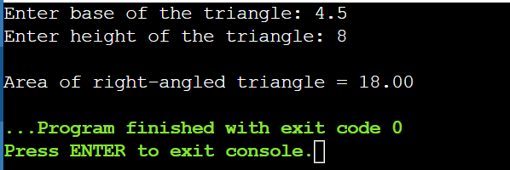

Write a program to find area and volume of a cube

AREA OF CUBE

#include <stdio.h>

int main() {

int a, area;

printf ("Enter the side of a cube (a) : ");

scanf ("%d", &a);

area = 6 * (a * a);

printf ("\nArea of cube = %d * (%d * %d) = %d", 6, a, a, area);

return 0;

}

***OUTPUT:***

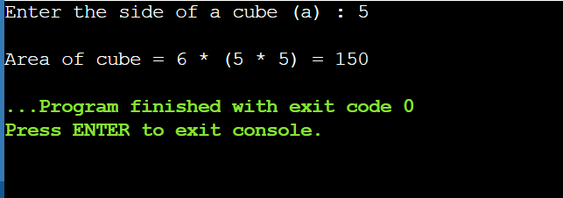

VOLUME OF CUBE

#include <stdio.h>

int main() {

int a, volume;

printf ("Enter the side of a cube (a) : ");

scanf ("%d", &a);

volume = a * a * a;

printf ("\nVolume of cube = %d * %d * %d = %d", a, a, a, volume);

return 0;

}

***OUTPUT:***

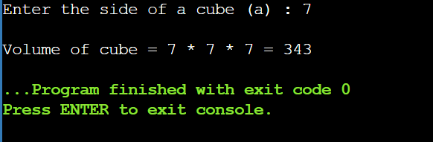

Write a program to find area and volume of a cuboid

AREA OF CUBOID

#include <stdio.h>

int main() {

int l, b, h, area;

printf ("Length of the cuboid : ");

scanf ("%d", &l);

printf ("Breadth of the cuboid : ");

scanf ("%d", &b);

printf ("Height of the cuboid : ");

scanf ("%d", &h);

area = 2 * (l*b + b*h + h*l);

printf ("\nArea of cuboid = %d * (%d*%d + %d*%d + %d*%d) = %d", 2,l,b,b,h,h,l, area);

return 0;

}

***OUTPUT:***

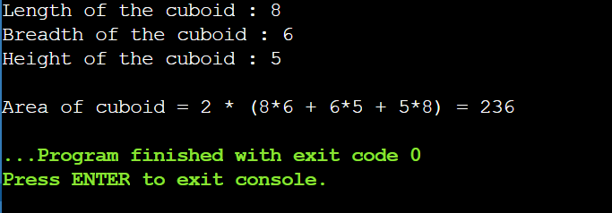

VOLUME OF CUBOID

#include <stdio.h>

int main() {

int l, b, h, volume;

printf ("Length of the cuboid : ");

scanf ("%d", &l);

printf ("Breadth of the cuboid : ");

scanf ("%d", &b);

printf ("Height of the cuboid : ");

scanf ("%d", &h);

volume = l * b * h;

printf ("\nVolume of cuboid = %d * %d * %d = %d", l, b, h, volume);

return 0;

}

***OUTPUT:***

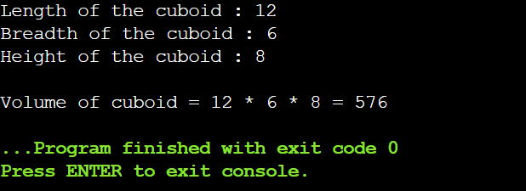

15. WAP to find the largest number using the logical AND operator.

#include <stdio.h>

int main() {

int n;

printf("ABHISHEK SHARMA\n");

printf("Enter the number of elements: ");

scanf("%d", &n);

if (n <= 0) {

printf("Invalid OUTPUT. Please enter a positive number of elements.\n");

return 1;

}

int largest;

int first = 1;

for (int i = 0; i < n; ++i) {

int num;

printf("Enter number %d: ", i + 1);

scanf("%d", &num);

if (first || (num > largest)) {

largest = num;

first = 0; // Set the flag to 0 after the first number is entered

}

}

printf("The largest number is: %d\n", largest);

return 0;

}

OUTPUT:

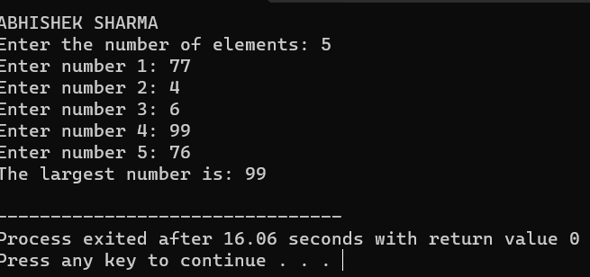

16. WAP to validate the username and password entered by the user is correct or not using the predefined username and password.

#include <stdio.h>

#include <string.h>

int main() {

char correctUsername[] = "manas";

char correctPassword[] = "123456789";

char enteredUsername[50];

char enteredPassword[50];

printf("ABHISHEK SHARMA\n");

printf("Enter username: ");

scanf("%s", enteredUsername);

printf("Enter password: ");

scanf("%s", enteredPassword);

if (strcmp(enteredUsername, correctUsername) == 0 && strcmp(enteredPassword, correctPassword) == 0) {

printf("Login successful!\n");

} else {

printf("Login failed. Please check your username and password.\n");

}

return 0;

}

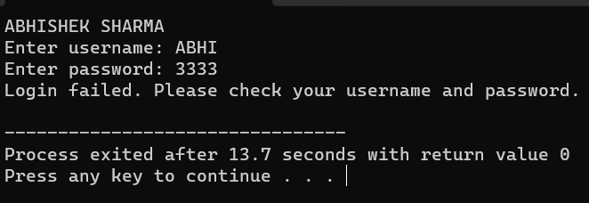

17. WAP to OUTPUT the positive number from the user to perform the left shift operator.

#include <stdio.h>

int main() {

int num, shift;

{

printf("ABHISHEK SHARMA\n");

printf("Enter a positive integer: ");

scanf("%d", &num);

if (num <= 0) {

printf("Please enter a positive integer.\n");

}

} while (num <= 0);

printf("Enter the number of positions to shift left: ");

scanf("%d", &shift);

int result = num << shift;

printf("Result of left shift: %d << %d = %d\n", num, shift, result);

return 0;

}

Output:

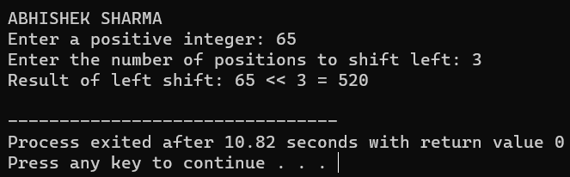

18. WAP to OUTPUT the positive number from the user to perform the right shift operator.

#include <stdio.h>

int main() {

int num, shift;

{

printf("ABHISHEK SHARMA\n");

printf("Enter a positive integer: ");

scanf("%d", &num);

if (num <= 0) {

printf("Please enter a positive integer.\n");

}

} while (num <= 0);

printf("Enter the number of positions to shift right: ");

scanf("%d", &shift);

int result = num >> shift;

printf("Result of right shift: %d >> %d = %d\n", num, shift, result);

return 0;

}

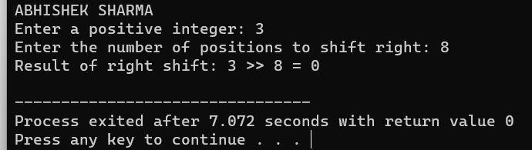

19. WAP to perform the pre increment and pre decrement operator on two integers and print both original value and updated value.

#include <stdio.h>

int main() {

int num1, num2;

printf("ABHISHEK SHARMA\n");

printf("Enter the first integer: ");

scanf("%d", &num1);

printf("Enter the second integer: ");

scanf("%d", &num2)

int preIncNum1 = ++num1;

int preDecNum2 = --num2;

printf("Original value of num1: %d\n", num1);

printf("Updated value of num1 (after pre-increment): %d\n", preIncNum1);

printf("Original value of num2: %d\n", num2);

printf("Updated value of num2 (after pre-decrement): %d\n", preDecNum2);

return 0;

}

Output:

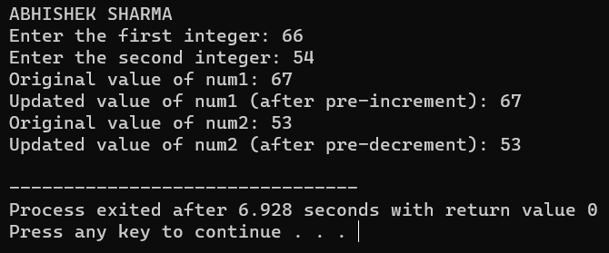

20. WAP to perform the post increment and post decrement operator on two integers and print both original value and updated value.

#include <stdio.h>

int main() {

int num1, num2;

printf("ABHISHEK SHARMA\n");

printf("Enter the first integer: ");

scanf("%d", &num1);

printf("Enter the second integer: ");

scanf("%d", &num2);

int postIncNum1 = num1++;

int postDecNum2 = num2--;

printf("Original value of num1: %d\n", num1);

printf("Updated value of num1 (after post-increment): %d\n", postIncNum1);

printf("Original value of num2: %d\n", num2);

printf("Updated value of num2 (after post-decrement): %d\n", postDecNum2);

return 0;

}

Output:



21. WAP for an integer number and to check whether it is divisible by 9 or 7 using OR logical operator.

#include <stdio.h>

int main() {

int num;

printf("ABHISHEK SHARMA\n");

printf("Enter an integer: ");

scanf("%d", &num);

if (num % 9 == 0 || num % 7 == 0) {

printf("%d is divisible by 9 or 7.\n", num);

} else {

printf("%d is not divisible by 9 or 7.\n", num);

}

return 0;

}

Output:

22. WAP to identify gender in single character and print full gender (Ex: if OUTPUT is 'M' or 'm' – it should print "Male").

#include <stdio.h>

int main() {

char gender;

printf("ABHISHEK SHARMA\n");

printf("Enter gender (M/F): ");

scanf(" %c", &gender);

switch (gender) {

case 'M':

case 'm':

printf("Male\n");

break;

case 'F':

case 'f':

printf("Female\n");

break;

default:

printf("Invalid gender OUTPUT\n");

}

return 0;

}

Output:

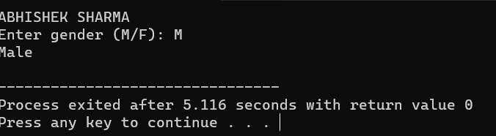

**23. Write a C program to print all natural numbers in reverse (from n to 1)**

#include <stdio.h>

int main() {

printf("ABHISHEK SHARMA");

int n;

// OUTPUT the value of n

printf("Enter a natural number (n): ");

scanf("%d", &n);

if (n <= 0) {

printf("Please enter a positive natural number.\n");

} else {

// Print numbers from n down to 1

for (int i = n; i >= 1; i--) {

printf("%d ", i);

}

printf("\n");

}

return 0;

}

**OUTPUT:**

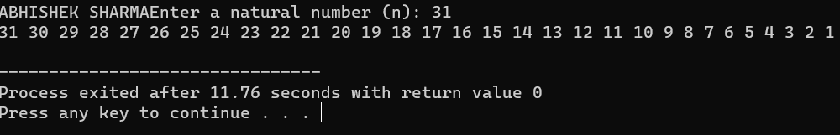

**24.Write a C program to print all alphabets from a to z.**

#include<stdio.h>

int main() {

int i;

printf("ABHISHEK SHARMA\n");

printf("\nAlphabets from (a to z) :\n");

for (i = 97; i <= 122; i++) { //ASCII value of a = 97

printf("%c ", i);

}

return 0;

}

**OUTPUT:**

**25. Write a C program to print all natural numbers from 1 to n.**

#include<stdio.h>

int main() {

int i, n;

printf("ABHISHEK SHARMA\n");

printf("\nEnter 'n': ");

scanf("%d", &n);

printf("\nNumbers from 1 to n =\n");

for (i = 1; i <= n; i++) {

printf("%d ", i);

}

return 0;

}

**OUTPUT:**

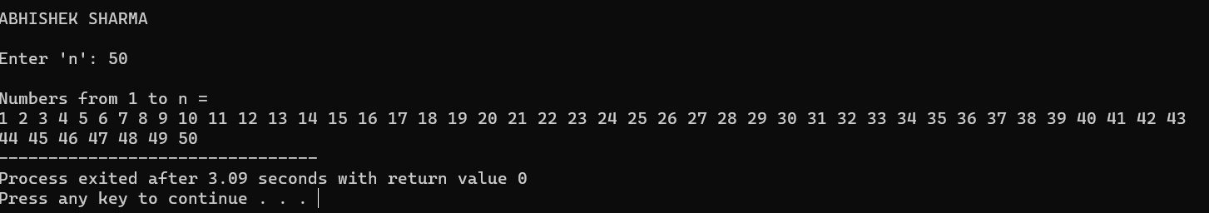

**26. Write a program to print all even numbers between 1 to 100.**

#include<stdio.h>

int main() {

int i;

printf("ABHISHEK SHARMA\n");

printf("\nEven numbers from 1 to 100 :\n");

for (i = 1; i <= 100; i++) {

if (i % 2 != 0) {

continue;

}

printf("%d ", i);

}

return 0;

}

**OUTPUT:**

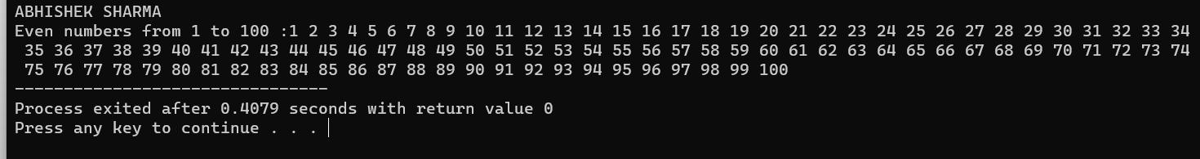

**27. Write a C program to print all odd number between 1 to 100.**

#include<stdio.h>

int main() {

int i;

printf("ABHISHEK SHARMA\n");

printf("\nOdd numbers from 1 to 100 :\n");

for (i = 1; i <= 100; i++) {

if (i % 2 == 0) {

continue;

}

printf("%d ", i);

}

return 0;

}

OUT**PUT:**

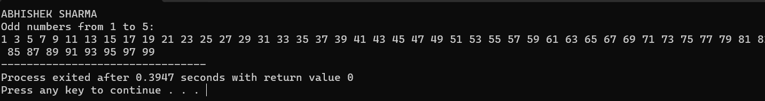

**28. Write a C program to find sum of all natural numbers between 1 to n.**

#include<stdio.h>

int main()

{

printf("ABHISHEK SHARMA");

int i, n, sum = 0;

printf("\nEnter any number: ");

scanf("%d", &n);

for (i = 1; i <= n; i++) {

printf("%d ", i);

sum = sum + i;

}

printf("\n\nSum of natural numbers from (1 to n) = %d", sum);

return 0;

}

**OUTPUT:**

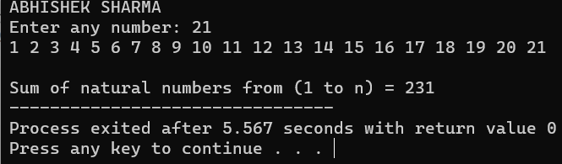

**29. Write a C program to find sum of all even numbers between 1 to n.**

#include<stdio.h>

int main()

{

printf("ABHISHEK SHARMA");

int i, n, sum = 0;

printf("\nEnter any number: ");

scanf("%d", &n);

for (i = 1; i <= n; i++) {

if (i % 2 != 0) {

continue;

}

printf("%d ", i);

sum = sum + i;

}

printf("\n\nSum of all even numbers from (1 to n) = %d", sum);

return 0;

}

**OUTPUT:**

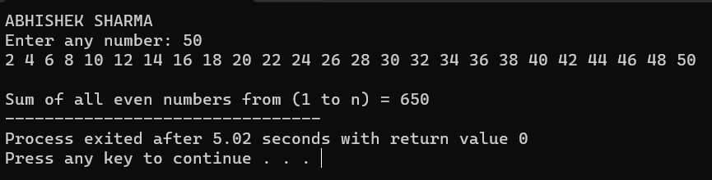

**30.Write a C program to find sum of all odd numbers between 1 to n.**

#include<stdio.h>

int main()

{

printf("ABHISHEK SHARMA");

int i, n, sum = 0;

printf("\nEnter any number: ");

scanf("%d", &n);

for (i = 1; i <= n; i++) {

if (i % 2 == 0) {

continue;

}

printf("%d ", i);

sum = sum + i;

}

printf("\n\nSum of all odd numbers from (1 to n) = %d", sum);

return 0;

}

**OUTPUT:**

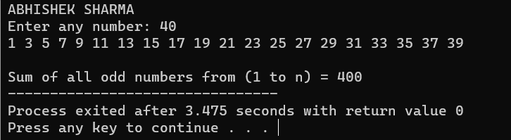

**31. Write a C program to print multiplication table of any number.**

#include<stdio.h>

int main()

{

printf("ABHISHEK SHARMA");

int i, n, product;

printf("\nEnter any number: ");

scanf("%d", &n);

for (i = 1; i <= 10; i++) {

product = n * i;

printf("%d * %d = %d\n", n, i, product);

}

return 0;

}

**OUTPUT:**

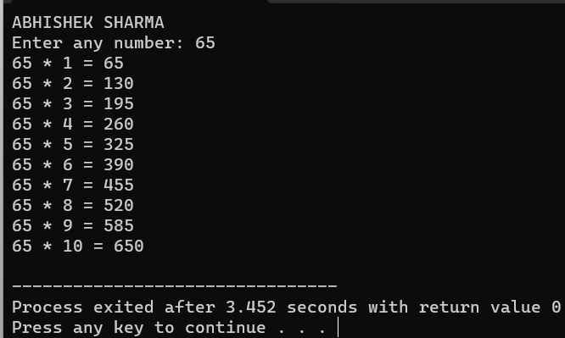

**32. Write a C program to count number of digits in a number.**

#include<stdio.h>

int main()

{

printf("\nABHISHEK SHARMA");

int n, count = 0;

printf("\nEnter any number: ");

scanf("%d", &n);

while (n > 0) {

n = n / 10;

count++;

}

printf("\nNumber of digits = %d", count);

return 0;

}

**OUTPUT:**

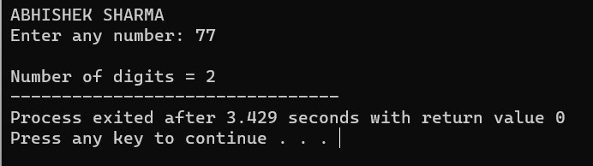

**33. Write a C program to find first and last digit of a number**

#include <stdio.h

int main() {

printf("ABHISHEK SHARMA");

int number, firstDigit, lastDigit;

printf("Enter a number: ");

scanf("%d", &number);

// Find the last digit

lastDigit = number % 10;

// Find the first digit

while (number >= 10) {

number /= 10;

}

firstDigit = number;

printf("First digit: %d\n", firstDigit);

printf("Last digit: %d\n", lastDigit);

return 0;

}

**OUTPUT:**

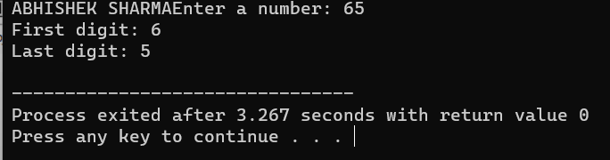

**34. Write a C program to find sum of first and last digit of a number**

#include <stdio.h>

int main() {

printf("ABHISHEK SHARMA");

int num, firstDigit, lastDigit, sum;

// OUTPUT a number from the user

printf("Enter a number: ");

scanf("%d", &num);

// Find the last digit

lastDigit = num % 10;

// Find the first digit

while (num >= 10) {

num /= 10;

}

firstDigit = num;

// Calculate the sum

sum = firstDigit + lastDigit;

// Display the result

printf("The sum of the first and last digits of the number is: %d\n", sum);

return 0;

}

**OUTPUT:**

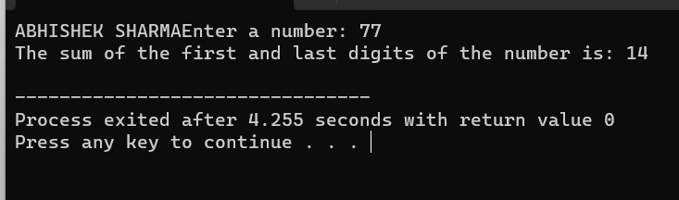

**35. Write a C program to swap first and last digits of a number.**

#include <stdio.h>

int main() {

printf("ABHISHEK SHARMA");

int number, originalNumber, firstDigit, lastDigit, temp;

printf("Enter a number: ");

scanf("%d", &number);

originalNumber = number;

// Get the last digit

lastDigit = number % 10;

// Find the number of digits in the given number

while (number >= 10) {

number /= 10;

}

// The first digit is now the remaining number

firstDigit = number;

// Swap the first and last digits

temp = firstDigit;

firstDigit = lastDigit;

lastDigit = temp;

// Reconstruct the new number

int swappedNumber = 0;

number = originalNumber;

while (number >= 10) {

swappedNumber = swappedNumber * 10 + (number % 10);

number /= 10;

}

swappedNumber = swappedNumber * 10 + number;

printf("Number after swapping: %d\n", swappedNumber);

return 0;

}

**OUTPUT:**

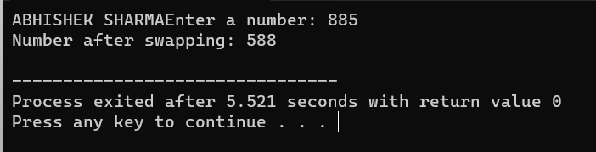

**36. Write a C program to calculate sum of digits of a number.**

#include <stdio.h>

int main() {

printf("ABHISHEK SHARMA");

int num, sum = 0, digit;

printf("Enter an integer: ");

scanf("%d", &num);

while (num > 0) {

digit = num % 10; // Get the last digit

sum += digit; // Add it to the sum

num = num / 10; // Remove the last digit

}

printf("The sum of the digits is: %d\n", sum);

return 0;

}

**OUTPUT:**

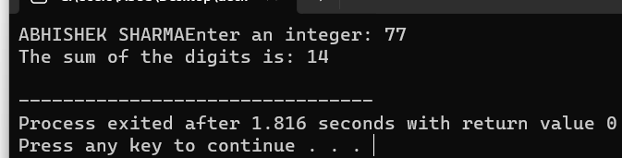

**37. Write a C program to calculate product of digits of a number**

#include <stdio.h>

int main() {

printf("ABHISHEK SHARMA");

int num, digit, product = 1;

/* OUTPUT number from the user */

printf("Enter a number: ");

scanf("%d", &num);

while (num != 0) {

digit = num % 10; // Get the last digit

product *= digit; // Multiply it with the product

num = num / 10; // Remove the last digit

}

printf("Product of digits = %d\n", product);

return 0;

}

**OUTPUT:**

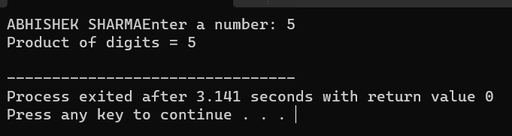

**38. Write a C program to enter a number and print its reverse.**

#include <stdio.h>

int main() {

printf("ABHISHEK SHARMA");

int num, reversed = 0;

printf("Enter a number: ");

scanf("%d", &num);

while (num != 0) {

int digit = num % 10;

reversed = reversed * 10 + digit;

num /= 10;

}

printf("Reversed number: %d\n", reversed);

return 0;

}

**OUTPUT:**

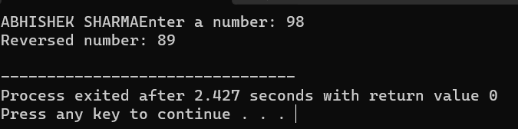

**39. Write a C program to check whether a number is palindrome or not.**

#include <stdio.h>

int main() {

printf("ABHISHEK SHARMA");

int num, originalNum, reversed = 0;

printf("Enter a number: ");

scanf("%d", &num);

originalNum = num; // Store the original number

// Reverse the number

while (num != 0) {

int digit = num % 10;

reversed = reversed * 10 + digit;

num /= 10;

}

// Check if the reversed number is the same as the original number

if (originalNum == reversed) {

printf("%d is a palindrome.\n", originalNum);

} else {

printf("%d is not a palindrome.\n", originalNum);

}

return 0;

}

**OUTPUT:**

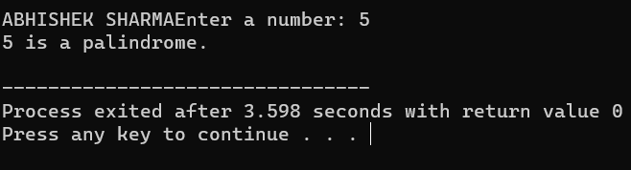

**40. Write a C program to find frequency of each digit in a given integer.**

#include <stdio.h>

int main() {

printf("ABHISHEK SHARMA");

int num, digit, count;

int frequency[10] = {0}; // Initialize an array to store the frequency of each digit

printf("Enter an integer: ");

scanf("%d", &num)

while (num != 0) {

digit = num % 10; // Get the last digit

frequency[digit]++; // Increment the count for that digit

num /= 10; // Remove the last digit

}

printf("Digit Frequency:\n");

for (digit = 0; digit <= 9; digit++) {

if (frequency[digit] > 0) {

printf("%d: %d times\n", digit, frequency[digit]);

}

}

return 0;

}

**OUTPUT:**

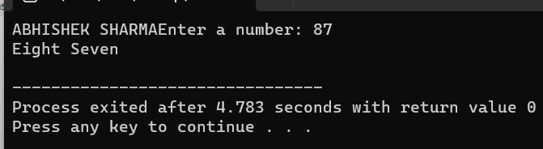

**41. Write a C program to enter a number and print it in words.**

#include <stdio.h>

// Function to print a number in words for single-digit numbers

void printDigitInWords(int digit) {

switch (digit) {

case 0:

printf("Zero ");

break;

case 1:

printf("One ");

break;

case 2:

printf("Two ");

break;

case 3:

printf("Three ");

break;

case 4:

printf("Four ");

break;

case 5:

printf("Five ");

break;

case 6:

printf("Six ");

break;

case 7:

printf("Seven ");

break;

case 8:

printf("Eight ");

break;

case 9:

printf("Nine ");

break;

}

}

int main() {

printf("ABHISHEK SHARMA");

int num, digit, reversed = 0;

printf("Enter a number: ");

scanf("%d", &num);

if (num == 0) {

printf("Zero\n");

return 0;

}

// Reverse the number to print it correctly

while (num != 0) {

digit = num % 10;

reversed = reversed * 10 + digit;

num /= 10;

}

// Print the number in words

while (reversed != 0) {

digit = reversed % 10;

printDigitInWords(digit);

reversed /= 10;

}

printf("\n");

return 0;

}

**OUTPUT:**



**42. Write a C program to print all ASCII character with their values.**

#include <stdio.h>

int main() {

printf("ABHISHEK SHARMA");

int i;

for (i = 0; i < 128; i++) {

printf("ASCII value %d represents character: %c\n", i, i);

}

return 0;

}

**OUTPUT:**

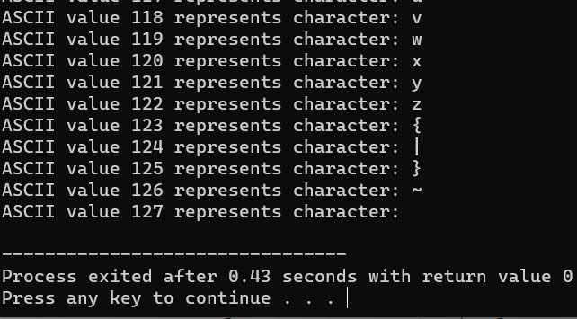

**43. Write a C program to find power of a number using for loop.**

#include <stdio.h

int main() {

printf("ABHISHEK SHARMA");

double base, exponent, result = 1;

// OUTPUT the base and exponent

printf("Enter the base: ");

scanf("%lf", &base);

printf("Enter the exponent: ");

scanf("%lf", &exponent);

// Calculate the power using a for loop

for (int i = 1; i <= exponent; i++) {

result *= base;

}

// Print the result

printf("%.2lf^%.2lf = %.2lf\n", base, exponent, result);

return 0;

}

**OUTPUT:**

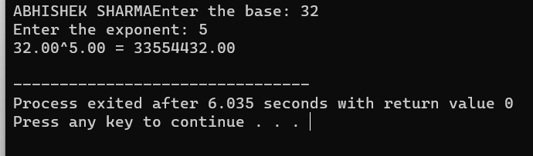

**44. Write a C program to find all factors of a number.**

#include <stdio.h>

int main() {

printf("ABHISHEK SHARMA");

int number;

// OUTPUT the number

printf("Enter a positive integer: ");

scanf("%d", &number);

if (number <= 0) {

printf("Please enter a positive integer.\n");

return 1; // Exit with an error code

}

printf("Factors of %d are: ", number);

// Use a for loop to find and print factors

for (int i = 1; i <= number; i++) {

if (number % i == 0) {

printf("%d ", i);

}

}

printf("\n");

return 0;

}

**OUTPUT:**

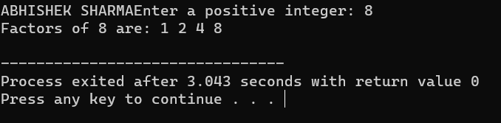

**45. Write a C program to calculate factorial of a number.**

#include <stdio.h>

int main() {

printf("ABHISHEK SHARMA");

int number;

unsigned long long factorial = 1;

// OUTPUT the number

printf("Enter a non-negative integer: ");

scanf("%d", &number);

if (number < 0) {

printf("Factorial is not defined for negative numbers.\n");

return 1; // Exit with an error code

}

// Calculate the factorial

for (int i = 1; i <= number; i++) {

factorial *= i;

}

// Print the result

printf("Factorial of %d is %llu\n", number, factorial);

return 0;

}

**OUTPUT:**

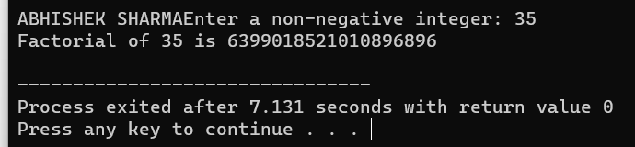

**46. Write a C program to find HCF (GCD) of two numbers.**

#include <stdio.h>

// Function to find the HCF/GCD of two numbers

int findGCD(int a, int b) {

if (b == 0) {

return a;

} else {

return findGCD(b, a % b);

}

}

int main() {

printf("ABHISHEK SHARMA");

int num1, num2;

printf("Enter two numbers: ");

scanf("%d %d", &num1, &num2);

int gcd = findGCD(num1, num2);

printf("The GCD of %d and %d is %d\n", num1, num2, gcd);

return 0;

}

**OUTPUT:**

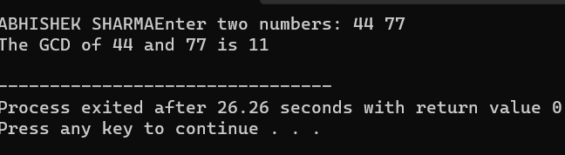

**47. Write a C program to find LCM of two numbers.**

#include <stdio.h>

// Function to find the GCD (HCF) of two numbers

int findGCD(int a, int b) {

if (b == 0) {

return a;

} else {

return findGCD(b, a % b);

}

}

// Function to find the LCM of two numbers

int findLCM(int a, int b) {

int gcd = findGCD(a, b);

int lcm = (a * b) / gcd;

return lcm;

}

int main() {

printf("ABHISHEK SHARMA");

int num1, num2;

printf("Enter two numbers: ");

scanf("%d %d", &num1, &num2);

int lcm = findLCM(num1, num2);

printf("The LCM of %d and %d is %d\n", num1, num2, lcm);

return 0;

}

**OUTPUT:**

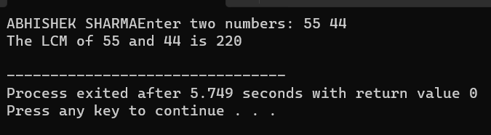

**48. Write a C program to check whether a number is Prime number or not.**

#include <stdio.h>

#include <stdbool.h>

// Function to check if a number is prime

bool isPrime(int n) {

if (n <= 1) {

return false; // 0 and 1 are not prime numbers

}

for (int i = 2; i * i <= n; i++) {

if (n % i == 0) {

return false; // n is divisible by i, so it's not prime

}

}

return true; // If no divisors are found, it's a prime number

}

int main() {

printf("ABHISHEK SHARMA");

int num;

printf("Enter a number: ");

scanf("%d", &num);

if (isPrime(num)) {

printf("%d is a prime number.\n", num);

} else {

printf("%d is not a prime number.\n", num);

}

return 0;

}

**OUTPUT:**

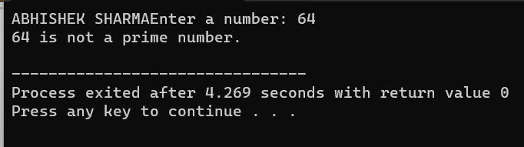

**49. Write a C program to print all Prime numbers between 1 to n.**

#include <stdio.h>

int isPrime(int num) {

if (num <= 1) return 0;

if (num <= 3) return 1;

if (num % 2 == 0 || num % 3 == 0) return 0;

for (int i = 5; i * i <= num; i += 6) {

if (num % i == 0 || num % (i + 2) == 0) {

return 0;

}

}

return 1;

}

int main() {

printf("ABHISHEK SHARMA");

int n;

printf("Enter the value of n: ");

scanf("%d", &n);

printf("Prime numbers between 1 and %d are:\n", n);

for (int i = 2; i <= n; i++) {

if (isPrime(i)) {

printf("%d ", i);

}

}

printf("\n");

return 0;

}

**OUTPUT:**

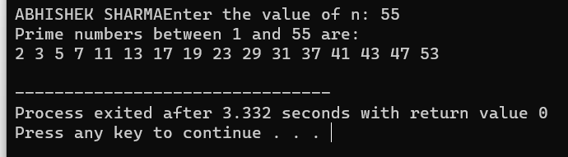

**50. Write a C program to find sum of all prime numbers between 1 to n.**

#include <stdio.h>

int isPrime(int num) {

if (num <= 1) return 0;

if (num <= 3) return 1;

if (num % 2 == 0 || num % 3 == 0) return 0;

for (int i = 5; i * i <= num; i += 6) {

if (num % i == 0 || num % (i + 2) == 0) {

return 0;

}

}

return 1;

}

int main() {

printf("ABHISHEK SHARMA");

int n;

printf("Enter the value of n: ");

scanf("%d", &n);

int sum = 0;

printf("Prime numbers between 1 and %d are:\n", n);

for (int i = 2; i <= n; i++) {

if (isPrime(i)) {

printf("%d ", i);

sum += i;

}

}

printf("\nSum of prime numbers between 1 and %d is: %d\n", n, sum);

return 0;

}

**OUTPUT:**

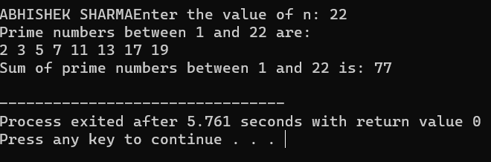

**51. Write a C program to find all prime factors of a number.**

#include <stdio.h>

// Function to find and print all prime factors of a number

void primeFactors(int n) {

// Print the number of 2s that divide n

while (n % 2 == 0) {

printf("2 ");

n = n / 2;

}

// n must be odd at this point, so a skip of 2 ( i = i + 2) can be used

for (int i = 3; i * i <= n; i = i + 2) {

// While i divides n, print i and divide n

while (n % i == 0) {

printf("%d ", i);

n = n / i;

}

}

// If n is a prime greater than 2

if (n > 2) {

printf("%d ", n);

}

}

int main() {

printf("ABHISHEK SHARMA");

int n;

printf("Enter a number: ");

scanf("%d", &n);

printf("Prime factors of %d are: ", n);

primeFactors(n);

return 0;

}

**OUTPUT:**

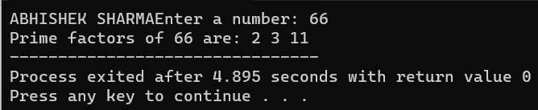

**52. Write a C program to check whether a number is Armstrong number or not.**

#include <stdio.h>

#include <math.h>

int isArmstrong(int num) {

int originalNum, remainder, n = 0, result = 0;

originalNum = num;

while (originalNum != 0) {

originalNum /= 10;

++n;

}

originalNum = num;

while (originalNum != 0) {

remainder = originalNum % 10;

result += pow(remainder, n);

originalNum /= 10;

}

if (result == num)

return 1; // It's an Armstrong number

else

return 0; // It's not an Armstrong number

}

int main() {

printf("ABHISHEK SHARMA");

int num;

printf("Enter a number: ");

scanf("%d", &num);

if (isArmstrong(num))

printf("%d is an Armstrong number.\n");

else

printf("%d is not an Armstrong number.\n");

return 0;

}

**OUTPUT:**

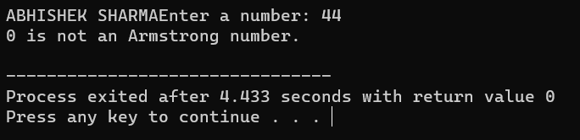

**53. Write a C program to print all Armstrong numbers between 1 to n.**

#include <stdio.h>

#include <math.h>

int isArmstrong(int num) {

int originalNum, remainder, result = 0, n = 0;

originalNum = num;

while (originalNum != 0) {

originalNum /= 10;

++n;

}

originalNum = num;

while (originalNum != 0) {

remainder = originalNum % 10;

result += pow(remainder, n);

originalNum /= 10;

}

if (result == num)

return 1;

else

return 0;

}

int main() {

printf("ABHISHEK SHARMA");

int n, i;

printf("Enter the value of n: ");

scanf("%d", &n);

printf("Armstrong numbers between 1 and %d are:\n", n);

for (i = 1; i <= n; i++) {

if (isArmstrong(i))

printf("%d\n", i);

}

return 0;

}

**OUTPUT:**

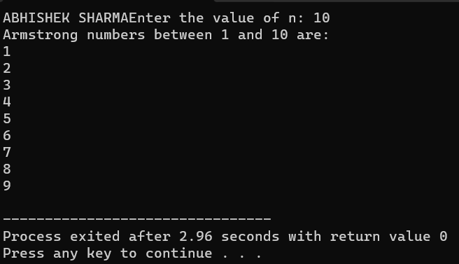

**54. Write a C program to check whether a number is Perfect number or not.**#include <stdio.h>

int Perfect(int num) {

int sum = 0;

for (int i = 1; i <= num / 2; i++) {

if (num % i == 0) {

sum += i;

}

}

return (sum == num);

}

int main() {

printf("ABHISHEK SHARMA");

int num;

printf("Enter a number: ");

scanf("%d", &num);

if (isPerfect(num)) {

printf("%d is a perfect number.\n", num);

} else {

printf("%d is not a perfect number.\n", num);

}

return 0;

}

**OUTPUT:**

**55. Write a C program to print all Perfect numbers between 1 to n.**

#include <stdio.h>

int isPerfect(int num) {

int sum = 0;

for (int i = 1; i <= num / 2; i++) {

if (num % i == 0) {

sum += i;

}

}

return (sum == num);

}

int main() {

printf("ABHISHEK SHARMA");

int n;

printf("Enter a positive integer n: ");

scanf("%d", &n);

printf("Perfect numbers between 1 and %d are: \n", n);

for (int i = 1; i <= n; i++) {

if (isPerfect(i)) {

printf("%d\n", i);

}

}

return 0;

}

**OUTPUT:**

**56. Write a C program to check whether a number is Strong number or not.**

#include <stdio.h>

// Function to calculate the factorial of a number

int factorial(int num) {

int fact = 1;

for (int i = 1; i <= num; i++) {

fact *= i;

}

return fact;

}

// Function to check if a number is a strong number

int isStrongNumber(int num) {

int originalNum = num;

int sum = 0;

while (num > 0) {

int digit = num % 10;

sum += factorial(digit);

num /= 10;

}

return (sum == originalNum);

}

int main() {

printf("ABHISHEK SHARMA");

int n;

printf("Enter a positive integer: ");

scanf("%d", &n);

if (isStrongNumber(n)) {

printf("%d is a Strong number.\n");

} else {

printf("%d is not a Strong number.\n");

}

return 0;

}

**OUTPUT:**

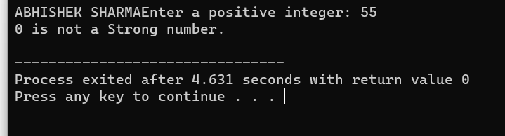

**57. Write a C program to print all Strong numbers between 1 to n.**

#include <stdio.h>

// Function to calculate the factorial of a number

int factorial(int num) {

int fact = 1;

for (int i = 1; i <= num; i++) {

fact *= i;

}

return fact;

}

// Function to check if a number is a strong number

int isStrongNumber(int num) {

int originalNum = num;

int sum = 0;

while (num > 0) {

int digit = num % 10;

sum += factorial(digit);

num /= 10;

}

return (sum == originalNum);

}

int main() {

printf("ABHISHEK SHARMA");

int n;

printf("Enter a positive integer n: ");

scanf("%d", &n);

printf("Strong numbers between 1 and %d are: \n", n);

for (int i = 1; i <= n; i++) {

if (isStrongNumber(i)) {

printf("%d\n", i);

}

}

return 0;

}

**OUTPUT:**

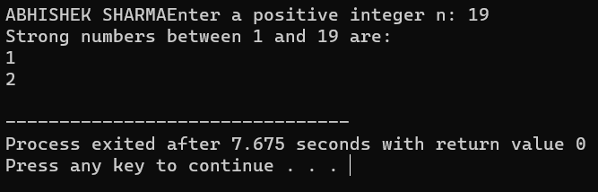

**58. Write a C program to print Fibonacci series up to n terms.**

#include <stdio.h>

int main() {

printf("ABHISHEK SHARMA");

int n, first = 0, second = 1, next;

printf("Enter the number of terms: ");

scanf("%d", &n);

printf("Fibonacci Series up to %d terms: \n", n);

for (int i = 1; i <= n; i++) {

if (i == 1) {

printf("%d, ", first);

} else if (i == 2) {

printf("%d, ", second);

} else {

next = first + second;

printf("%d, ", next);

first = second;

second = next;

}

}

printf("\n");

return 0;

}

OUTPUT:

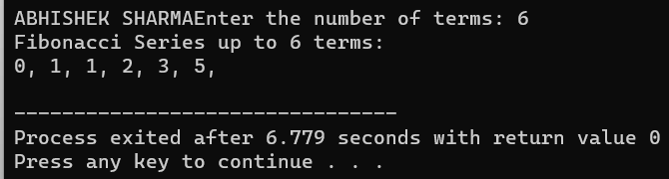

**59. Write a C program to find one's complement of a binary number.**

#include <stdio.h>

int main() {

printf("ABHISHEK SHARMA");

char binary[32]; // Assuming a maximum of 32-bit binary number

int length, i;

printf("Enter a binary number: ");

scanf("%s", binary);

// Find the length of the binary number

length = strlen(binary);

// Perform one's complement

for (i = 0; i < length; i++) {

if (binary[i] == '0') {

binary[i] = '1';

} else if (binary[i] == '1') {

binary[i] = '0';

}

}

printf("One's complement: %s\n", binary);

return 0;

}

**OUTPUT:**

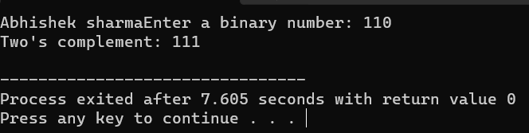

**60. Write a C program to find two's complement of a binary number.**

#include <stdio.h>

#include <string.h>

// Function to reverse a binary string

void reverseString(char str[]) {

int length = strlen(str);

for (int i = 0; i < length / 2; i++) {

char temp = str[i];

str[i] = str[length - i - 1];

str[length - i - 1] = temp;

}

}

// Function to add 1 to a binary string

void addOne(char binary[]) {

int length = strlen(binary);

int carry = 1;

for (int i = 0; i < length; i++) {

if (binary[i] == '0' && carry == 1) {

binary[i] = '1';

carry = 0;

} else if (binary[i] == '1' && carry == 1) {

binary[i] = '0';

}

}

}

int main() {

printf ("ABHISHEK SHARMA");

char binary[32]; // Assuming a maximum of 32-bit binary number

printf("Enter a binary number: ");

scanf("%s", binary);

// Reverse the binary string

reverseString(binary);

// Add 1 to the reversed binary string

addOne(binary);

// Reverse the result to get the two's complement

reverseString(binary);

printf("Two's complement: %s\n", binary);

return 0;

}

**OUTPUT:**

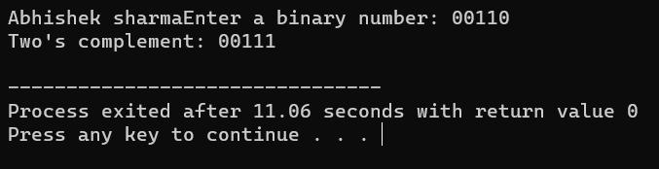

**61. Write a C program to convert Binary to Octal number system.**

#include <stdio.h>

#include <string.h>

// Function to convert a binary number to an octal number

void binaryToOctal(char binary[]) {

int length = strlen(binary);

// Pad the binary number with leading zeros if needed to make the length a multiple of 3

int padding = (3 - (length % 3)) % 3;

for (int i = 0; i < padding; i++) {

printf("0");

}

// Iterate through the binary number in groups of 3 and convert to octal

for (int i = padding; i < length; i += 3) {

int octalDigit = (binary[i] - '0') * 4 + (binary[i + 1] - '0') * 2 + (binary[i + 2] - '0');

printf("%d", octalDigit);

}

printf("\n");

}

int main() {

printf("ABHISHEK SHARMA");

char binary[32]; // Assuming a maximum of 32-bit binary number

printf("Enter a binary number: ");

scanf("%s", binary);

printf("Octal representation: ");

binaryToOctal(binary);

return 0;

}

**OUTPUT:**

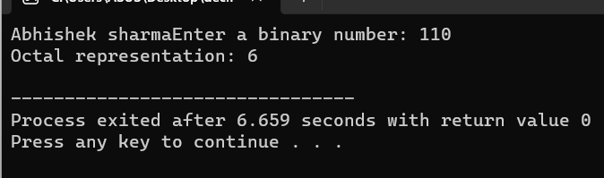

**62. Write a C program to convert Binary to Decimal number system.**#include <stdio.h>

#include <string.h>

// Function to convert a binary number to decimal

int binaryToDecimal(char binary[]) {

int length = strlen(binary);

int decimal = 0;

int base = 1;

for (int i = length - 1; i >= 0; i--) {

if (binary[i] == '1') {

decimal += base;

}

base *= 2;

}

return decimal;

}

int main() {

printf("ABHISHEK SHARMA");

char binary[32]; // Assuming a maximum of 32-bit binary number

printf("Enter a binary number: ");

scanf("%s", binary);

int decimal = binaryToDecimal(binary);

printf("Decimal representation: %d\n", decimal);

return 0;

}

**OUTPUT:**

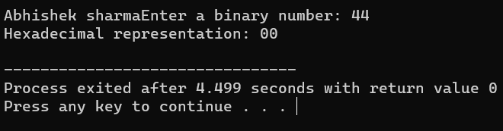

**63. Write a C program to convert Binary to Hexadecimal number system.**

#include <stdio.h>

#include <string.h>

// Function to convert a binary number to hexadecimal

void binaryToHexadecimal(char binary[]) {

int length = strlen(binary);

// Pad the binary number with leading zeros if needed to make the length a multiple of 4

int padding = (4 - (length % 4)) % 4;

for (int i = 0; i < padding; i++) {

printf("0");

}

// Iterate through the binary number in groups of 4 and convert to hexadecimal

for (int i = padding; i < length; i += 4) {

int hexDigit = 0;

for (int j = 0; j < 4; j++) {

hexDigit = (hexDigit << 1) | (binary[i + j] - '0');

}

if (hexDigit < 10) {

printf("%d", hexDigit);

} else {

printf("%c", 'A' + hexDigit - 10);

}

}

printf("\n");

}

int main() {

printf("ABHISHEK SHARMA");

char binary[32]; // Assuming a maximum of 32-bit binary number

printf("Enter a binary number: ");

scanf("%s", binary);

printf("Hexadecimal representation: ");

binaryToHexadecimal(binary);

return 0;

}

**OUTPUT:**

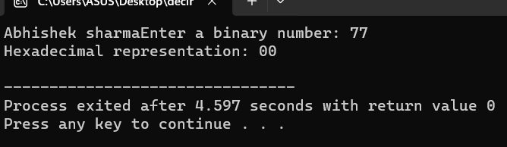

**64. Write a C program to convert Octal to Binary number system.**

#include <stdio.h>

#include <string.h>

// Function to convert an octal digit to a binary string

char *octalToBinary(char octalDigit) {

switch (octalDigit) {

case '0': return "000";

case '1': return "001";

case '2': return "010";

case '3': return "011";

case '4': return "100";

case '5': return "101";

case '6': return "110";

case '7': return "111";

default: return "Invalid";

}

}

int main() {

printf("ABHISHEK SHARMA");

char octal[32]; // Assuming a maximum of 32-bit octal number

char binary[128]; // To store the binary equivalent

printf("Enter an octal number: ");

scanf("%s", octal);

int length = strlen(octal);

int binaryIndex = 0;

// Convert each octal digit to binary and concatenate

for (int i = 0; i < length; i++) {

char *binaryDigit = octalToBinary(octal[i]);

// Skip the first digit if it results in leading zeros

if (i == 0 && binaryDigit[0] == '0') {

binaryDigit += 1;

}

// Copy the binary digits to the binary string

strcpy(binary + binaryIndex, binaryDigit);

binaryIndex += strlen(binaryDigit);

}

printf("Binary representation: %s\n", binary);

return 0;

}

**OUTPUT:**

**65. Write a C program to convert Octal to Decimal number system.**

#include <stdio.h>

#include <math.h>

int octalToDecimal(char octal[]) {

int length = 0;

while (octal[length] != '\0') {

length++;

}

int decimal = 0;

int base = 1;

for (int i = length - 1; i >= 0; i--) {

if (octal[i] < '0' || octal[i] > '7') {

printf("Invalid octal digit: %c\n", octal[i]);

return -1;

}

int octalDigit = octal[i] - '0';

decimal += octalDigit * base;

base *= 8;

}

return decimal;

}

int main() {

printf("ABHISHEK SHARMA");

char octal[32]; // Assuming a maximum of 32-bit octal number

printf("Enter an octal number: ");

scanf("%s", octal);

int decimal = octalToDecimal(octal);

if (decimal != -1) {

printf("Decimal representation: %d\n", decimal);

}

return 0;

}

**OUTPUT:**

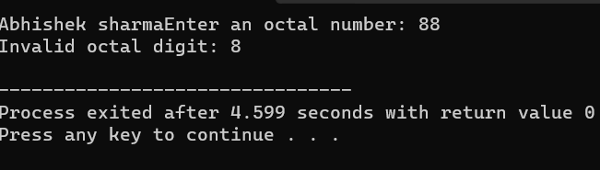

66. Write a C program to convert Octal to Hexadecimal number system.

#include <stdio.h>

#include <string.h>

// Function to convert octal to decimal

int octalToDecimal(char octal[]) {

int decimal = 0, i = 0, len = strlen(octal);

while (len--) {

decimal += (octal[len] - '0') * (1 << (3 * i));

i++;

}

return decimal;

}

// Function to convert decimal to hexadecimal

void decimalToHexadecimal(int decimal) {

char hexadecimal[100];

int i = 0;

while (decimal > 0) {

int remainder = decimal % 16;

if (remainder < 10)

hexadecimal[i++] = remainder + '0';

else

hexadecimal[i++] = remainder + 'A' - 10;

decimal /= 16;

}

printf("Hexadecimal equivalent: ");

for (int j = i - 1; j >= 0; j--) {

printf("%c", hexadecimal[j]);

}

}

int main() {

char octal[100];

printf("Enter an octal number: ");

scanf("%s", octal);

int decimal = octalToDecimal(octal);

decimalToHexadecimal(decimal);

return 0;

}

OUTPUT:

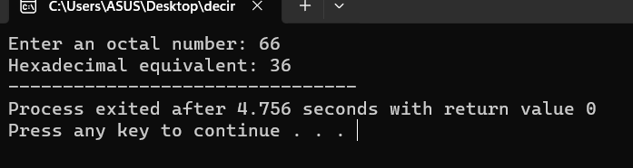

67. Write a C program to convert Decimal to Binary number system.

#include <stdio.h>

void decimalToBinary(int decimal) {

if (decimal == 0) {

printf("Binary: 0\n");

return;

}

int binary[32];

int i = 0;

while (decimal > 0) {

binary[i] = decimal % 2;

decimal /= 2;

i++;

}

printf("Binary: ");

for (int j = i - 1; j >= 0; j--) {

printf("%d", binary[j]);

}

printf("\n");

}

int main() {

printf("ABHISHEK SHARMA ");

int decimal;

printf("Enter a decimal number: ");

scanf("%d", &decimal);

decimalToBinary(decimal);

return 0;

}

OUTPUT:

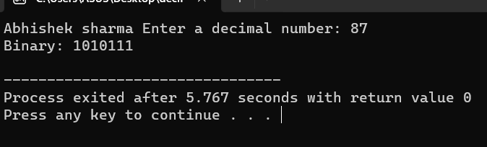

68. Write a C program to convert Decimal to Octal number system.

#include <stdio.h>

int main() {

printf("ABHISHEK SHARMA ");

int decimal, octal[100], i = 0;

printf("Enter a decimal number: ");

scanf("%d", &decimal);

while (decimal > 0) {

octal[i] = decimal % 8;

decimal /= 8;

i++;

}

printf("Octal equivalent: ");

for (int j = i - 1; j >= 0; j--) {

printf("%d", octal[j]);

}

return 0;

OUTPUT:

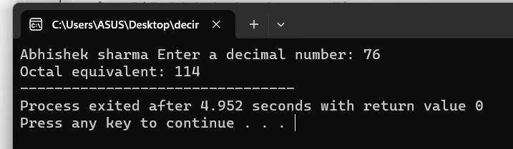

69. Write a C program to convert Decimal to Hexadecimal number system.

#include <stdio.h>

int main() {

printf("ABHISHEK SHARMA ");

int decimal, remainder, i = 0;

char hexadecimal[100];

printf("Enter a decimal number: ");

scanf("%d", &decimal);

while (decimal > 0) {

remainder = decimal % 16;

if (remainder < 10) {

hexadecimal[i] = remainder + '0';

} else {

hexadecimal[i] = remainder - 10 + 'A';

}

decimal /= 16;

i++;

}

printf("Hexadecimal equivalent: 0x");

for (int j = i - 1; j >= 0; j--) {

printf("%c", hexadecimal[j]);

}

return 0;

}

OUTPUT:

70. Write a C program to convert Hexadecimal to Binary number system.

#include <stdio.h>

#include <string.h>

int main() {

printf("ABHISHEK SHARMA ");

char hexadecimal[100];

printf("Enter a hexadecimal number: ");

scanf("%s", hexadecimal);

int length = strlen(hexadecimal);

printf("Binary equivalent: ");

for (int i = 0; i < length; i++) {

char hexDigit = hexadecimal[i];

int decimalValue;

if (hexDigit >= '0' && hexDigit <= '9') {

decimalValue = hexDigit - '0';

} else if (hexDigit >= 'A' && hexDigit <= 'F') {

decimalValue = hexDigit - 'A' + 10;

} else if (hexDigit >= 'a' && hexDigit <= 'f') {

decimalValue = hexDigit - 'a' + 10;

} else {

printf("Invalid hexadecimal OUTPUT.\n");

return 1;

}

for (int j = 3; j >= 0; j--) {

if (decimalValue & (1 << j)) {

printf("1");

} else {

printf("0");

}

}

}

printf("\n");

return 0;

}

OUTPUT:

71. Write a C program to convert Hexadecimal

to Octal number system

#include <stdio.h>

#include <string.h>

int main() {

printf("ABHISHEK SHARMA ");

char hex[20];

printf("Enter a hexadecimal number: ");

scanf("%s", hex);

long int dec = 0, oct = 0, i = 0;

// Convert hexadecimal to decimal

for (int j = strlen(hex) - 1; j >= 0; j--) {

int digit;

if (hex[j] >= '0' && hex[j] <= '9')

digit = hex[j] - '0';

else if (hex[j] >= 'A' && hex[j] <= 'F')

digit = hex[j] - 'A' + 10;

else if (hex[j] >= 'a' && hex[j] <= 'f')

digit = hex[j] - 'a' + 10;

dec += digit * (1 << (4 * i));

i++;

}

i = 1;

// Convert decimal to octal

while (dec != 0) {

oct += (dec % 8) * i;

dec /= 8;

i *= 10;

}

printf("The octal equivalent is: %lo\n", oct);

return 0;

}

OUTPUT:

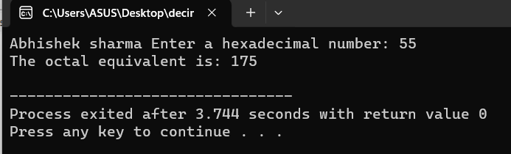

72. Write a C program to convert Hexadecimal to Decimal number system.

#include <stdio.h>

#include <math.h>

int main() {

printf("ABHISHEK SHARMA ");

char hexNum[10];

int decimalNum = 0;

int i, j, len;

printf("Enter a hexadecimal number: ");

scanf("%s", hexNum);

// Find the length of the hexadecimal number

len = strlen(hexNum);

// Iterate through the hexadecimal number in reverse order

for (i = 0; hexNum[i] != '\0'; i++) {

len--;

if (hexNum[i] >= '0' && hexNum[i] <= '9')

j = hexNum[i] - '0';

else if (hexNum[i] >= 'a' && hexNum[i] <= 'f')

j = hexNum[i] - 'a' + 10;

else if (hexNum[i] >= 'A' && hexNum[i] <= 'F')

j = hexNum[i] - 'A' + 10;

decimalNum += j * pow(16, len);

}

printf("Decimal equivalent: %d\n", decimalNum);

return 0;

}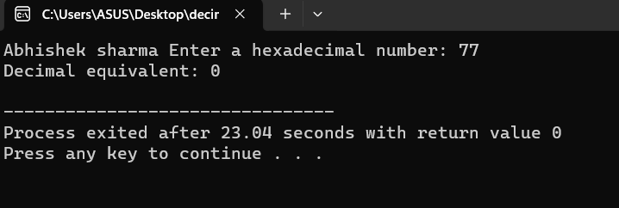

**Pattern Exercises**

1. Star pattern programs - Write a C program to print the given star patterns.

*

***

*****

*******

*********

**Pyramid Star Pattern**

#include <stdio.h>

void printStarPattern(int n) {

for(int i = 1; i <= n; i++) {

for(int j = 1; j <= 2*i-1; j++) {

printf("*");

}

printf("\n");

}

}

int main() {

int n = 5; // Change this value to adjust the number of rows

printStarPattern(n);

return 0;

}

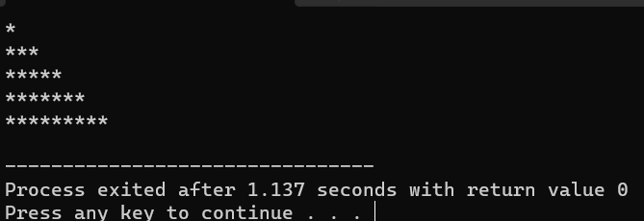

2. *

* *

* *

* *

*********

**Hollow Pyramid Star Pattern**

#include <stdio.h>

void printHollowPyramid(int n) {

int i, j;

// Print upper part of the pyramid

for(i = 1; i <= n; i++) {

for(j = i; j < n; j++) {

printf(" ");

}

for(j = 1; j <= 2*i-1; j++) {

if(j == 1 || j == 2*i-1 || i == n) {

printf("*");

}

else {

printf(" ");

}

}

printf("\n");

}

}

int main() {

int n;

printf("Enter the number of rows: ");

scanf("%d", &n);

if(n <= 0) {

printf("Invalid input. Please enter a positive integer.\n");

return 1;

}

printHollowPyramid(n);

return 0;

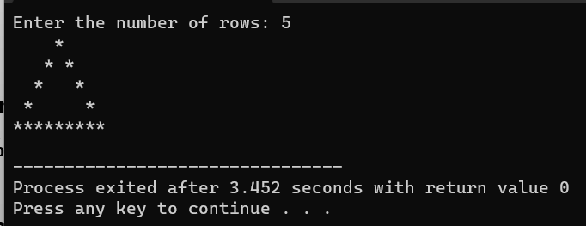}

*********

*******

*****

***

*

**3.Inverted Pyramid Star Pattern**

#include <stdio.h>

int main() {

int i, j, rows;

printf("Enter the number of rows: ");

scanf("%d", &rows);

for(i = rows; i >= 1; --i) {

for(j = 1; j <= i; ++j) {

printf("* ");

}

printf("\n");

}

return 0;

}

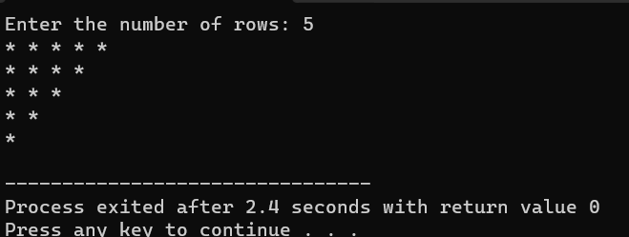

*********

* *

* *

* *

*

4.Hollow Inverted Pyramid Star Pattern

#include <stdio.h>

int main() {

int rows, i, j;

printf("Enter the number of rows: ");

scanf("%d", &rows);

for(i = 1; i <= rows; i++) {

// Print spaces

for(j = 1; j < i; j++) {

printf(" ");

}

// Print stars for the first row or the last row

if(i == 1 || i == rows) {

for(j = 1; j <= (2 * (rows - i) + 1); j++) {

printf("*");

}

} else { // Print stars for other rows

printf("*");

for(j = 1; j < (2 * (rows - i)); j++) {

printf(" ");

}

printf("*");

}

printf("\n");

}

return 0;

}

*****

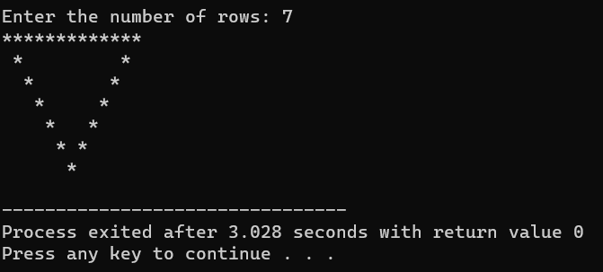

*

***

****

****

***

**

*

**5.Half Diamond Star Pattern**

#include <stdio.h>

int main() {

int i, j, rows;

printf("Enter the number of rows: ");

scanf("%d", &rows);

// Print upper half of the diamond

for(i = 1; i <= rows; i++) {

for(j = 1; j <= i; j++) {

printf("*");

}

printf("\n");

}

// Print lower half of the diamond

for(i = rows-1; i >= 1; i--) {

for(j = 1; j <= i; j++) {

printf("*");

}

printf("\n");

}

return 0;

}

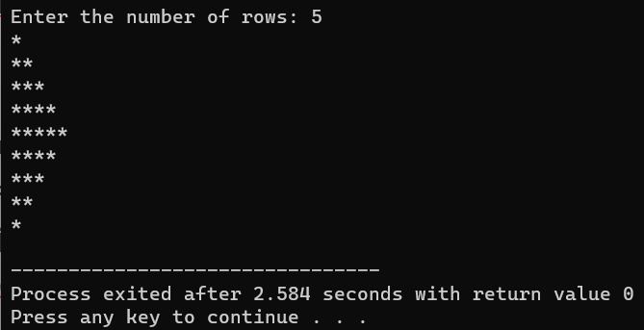

*

**

***

****

*****

****

***

**

*

6.Mirrored Half Diamond Star Pattern

#include <stdio.h>

void printHalfDiamond(int n) {

int i, j;

// Upper half of the pattern

for(i = 1; i <= n; i++) {

for(j = 1; j <= i; j++) {

printf("*");

}

printf("\n");

}

// Lower half of the pattern

for(i = n-1; i >= 1; i--) {

for(j = 1; j <= i; j++) {

printf("*");

}

printf("\n");

}

}

int main() {

int n;

// Get user input for the number of rows

printf("Enter the number of rows: ");

scanf("%d", &n);

// Call the function to print the pattern

printHalfDiamond(n);

return 0;

}

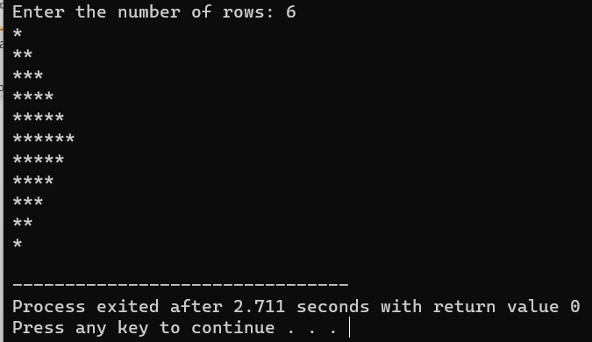

**2. Number pattern programs - Write a C program to print the given number patterns**

**Square number patterns**

**11111**

**11111**

**11111**

**11111**

**11111**

#include <stdio.h>

int main() {

int i, j;

for(i = 0; i < 5; i++) {

for(j = 0; j < 5; j++) {

printf("1");

}

printf("\n");

}

return 0;

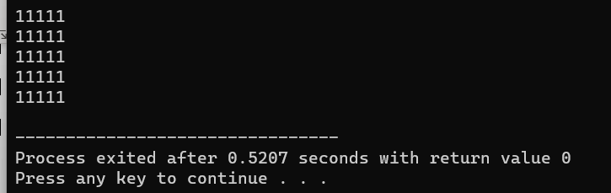}

**Number pattern 1**

**11111**

**00000**

**11111**

**00000**

**11111**

#include <stdio.h>

int main() {

int i, j;

for (i = 1; i <= 5; i++) {

for (j = 1; j <= 5; j++) {

if (i % 2 == 1) {

printf("1");

} else {

printf("0");

}

}

printf("\n");

}

return 0;

}

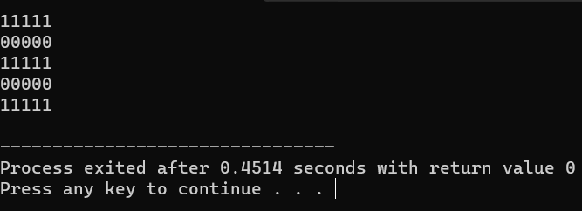

**Number pattern 2**

**01010**

**01010**

**01010**

**01010**

**01010**

#include <stdio.h>

int main() {

int i, j;

for(i = 1; i <= 5; i++) {

for(j = 1; j <= 5; j++) {

if(j % 2 == 0) {

printf("1");

} else {

printf("0");

}

}

printf("\n");

}

return 0;

}

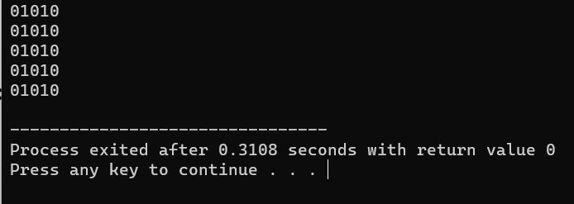

**Number pattern 3**

**11111**

**10001**

**10001**

**10001**

**11111**

#include <stdio.h>

int main() {

int n = 5; // Number of rows and columns

for (int i = 0; i < n; i++) {

for (int j = 0; j < n; j++) {

if (i == 0 || i == n - 1 || j == 0 || j == n - 1)

printf("1");

else

printf("0");

}

printf("\n");

}

return 0;

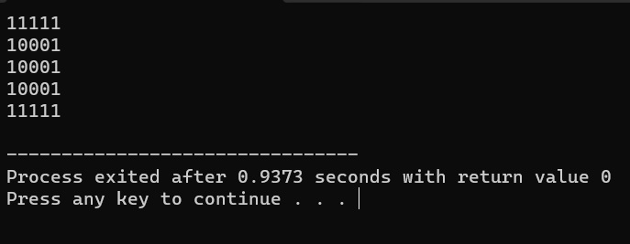}

**Number pattern 4**

**11111**

**11111**

**11011**

**11111**

**11111**

#include <stdio.h>

int main() {

int n = 5; // Size of the pattern (5x5 in this case)

for(int i = 0; i < n; i++) {

for(int j = 0; j < n; j++) {

if (i == n/2 && j == n/2) { // If we're at the center, print 0

printf("0");

} else {

printf("1");

}

}

printf("\n"); // Move to the next line after each row

}

return 0;

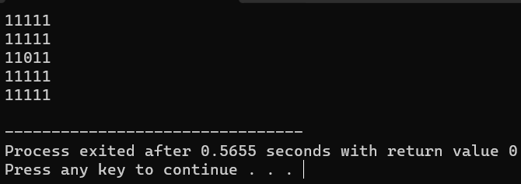}

**Number pattern 5**

**10101**

**01010**

**10101**

**01010**

**10101**

#include <stdio.h>

int main() {

int rows = 5;

int cols = 5;

for(int i = 0; i < rows; i++) {

for(int j = 0; j < cols; j++) {

if((i+j) % 2 == 0) {

printf("1");

} else {

printf("0");

}

}

printf("\n");

}

return 0;

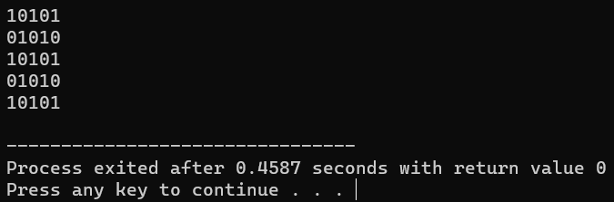}

**If…Else Exercises**

1. Write a C program to find maximum between two numbers.

#include <stdio.h>

int main() {

int num1, num2;

// Input the two numbers

printf("Enter first number: ");

scanf("%d", &num1);

printf("Enter second number: ");

scanf("%d", &num2);

// Compare the numbers

if (num1 > num2) {

printf("%d is the maximum\n", num1);

} else {

printf("%d is the maximum\n", num2);

}

return 0;

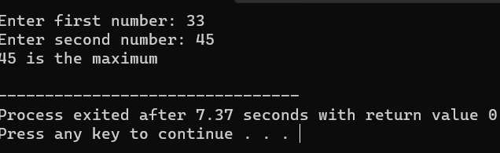}

1. **Write a C program to find maximum between three numbers**.

#include <stdio.h>

int findMax(int a, int b, int c) {

int max = a;

if (b > max) {

max = b;

}

if (c > max) {

max = c;

}

return max;

}

int main() {

int num1, num2, num3;

printf("Enter three numbers: ");

scanf("%d %d %d", &num1, &num2, &num3);

int max = findMax(num1, num2, num3);

printf("The maximum of %d, %d, and %d is %d\n", num1, num2, num3, max);

return 0;

}

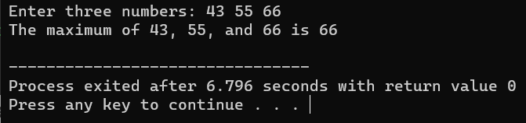

1. Write a C program to check whether a number is negative, positive or zero.

#include <stdio.h>

int main() {

int num;

// Read the number from the user

printf("Enter a number: ");

scanf("%d", &num);

if (num > 0) {

printf("%d is positive.\n", num);

} else if (num < 0) {

printf("%d is negative.\n", num);

} else {

printf("%d is zero.\n", num);

}

return 0;

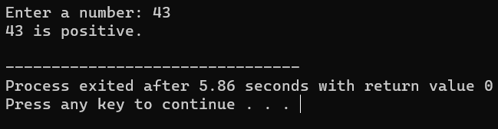}

1. Write a C program to check whether a number is divisible by 5 and 11 or not.

#include <stdio.h>

int main() {

int num;

// Read input from user

printf("Enter a number: ");

scanf("%d", &num);

// Check if the number is divisible by both 5 and 11

if (num % 5 == 0 && num % 11 == 0) {

printf("%d is divisible by both 5 and 11.\n", num);

} else {

printf("%d is not divisible by both 5 and 11.\n", num);

}

return 0;

}

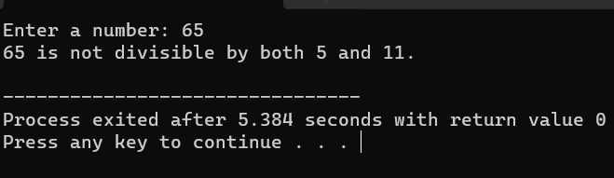

1. Write a C program to check whether a number is even or odd.

#include <stdio.h>

int main() {

int num;

// Prompt the user to enter a number

printf("Enter an integer: ");

scanf("%d", &num);

// Check if the number is even or odd

if (num % 2 == 0) {

printf("%d is even.\n", num);

} else {

printf("%d is odd.\n", num);

}

return 0;

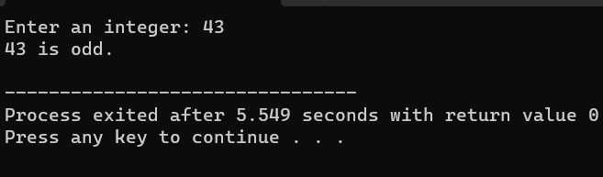}

1. Write a C program to check whether a year is leap year or not.

#include <stdio.h>

int main() {

int year;

// Input year from user

printf("Enter a year: ");

scanf("%d", &year);

// Check if the year is a leap year

if ((year % 4 == 0 && year % 100 != 0) || (year % 400 == 0)) {

printf("%d is a leap year.\n", year);

} else {

printf("%d is not a leap year.\n", year);

}

return 0;

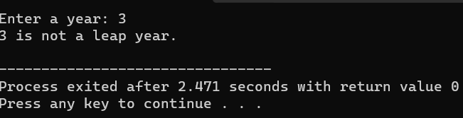}

THANK YOU